MEARN STACK ASSIGNMENT 1

- What is Web Development?
Web development is the process of creating, building, and maintaining websites or web applications that run on the internet or an intranet.
It involves everything from a simple static webpage to complex dynamic web apps like e-commerce sites, social media platforms, and dashboards.

Web development = Frontend (what users see) + Backend (how it works) + Database (where data is stored)
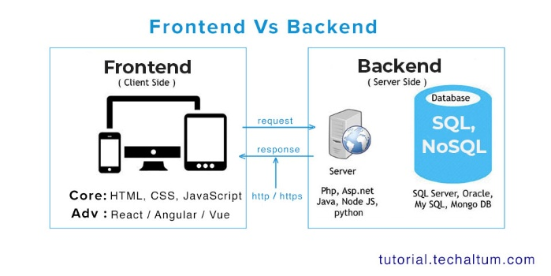
1. Frontend Development (Client Side)
Frontend is everything the user can see and interact with.
Technologies Used:
- HTML – Structure of the webpage
- CSS – Styling, layout, colors, fonts
- JavaScript – Interactivity (buttons, forms, animations)
2. Backend Development (Server Side)
Backend is the brain of the website.
Users don’t see it, but it controls everything.

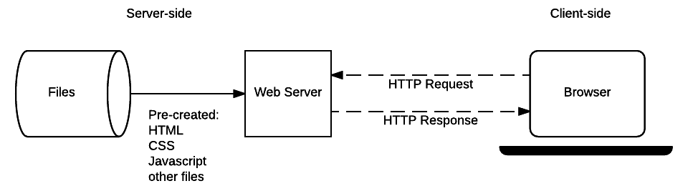
Backend Technologies:
- Languages: Java, Python, PHP, JavaScript (Node.js)
- Frameworks: Spring Boot, Django, Express

3. Database (Data Storage)
Database is where we stores data permanently. And during any processing required data is fetched from database when it triggers

Workflow
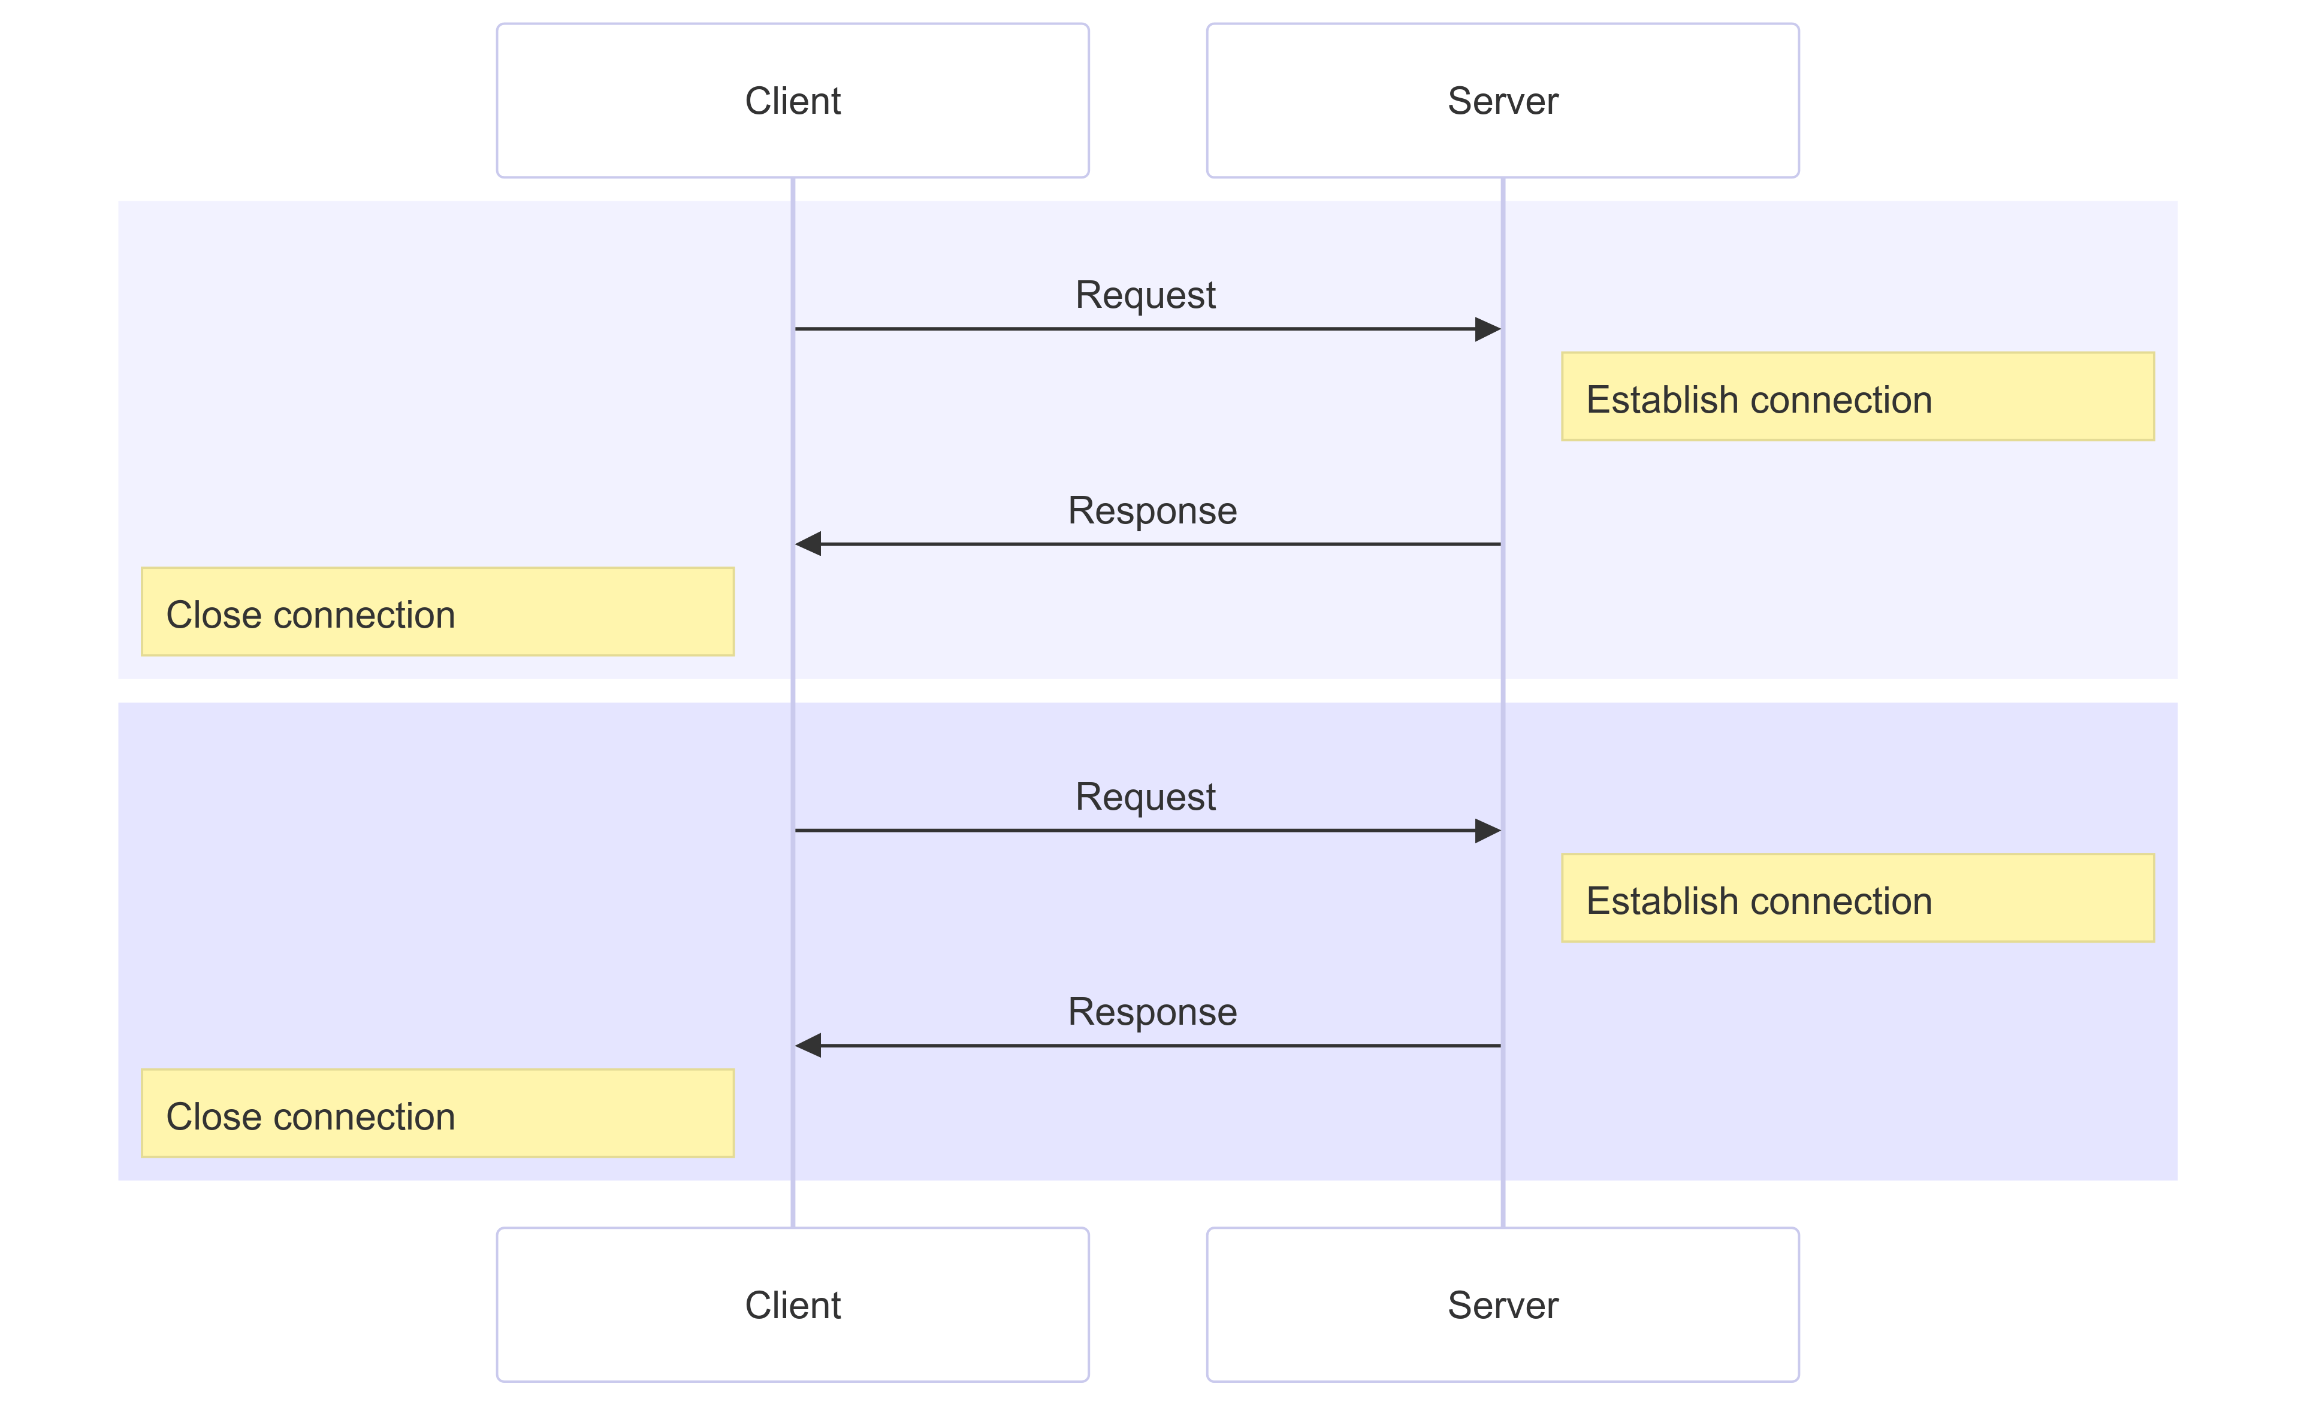

- Difference between frontend and backend with examples.
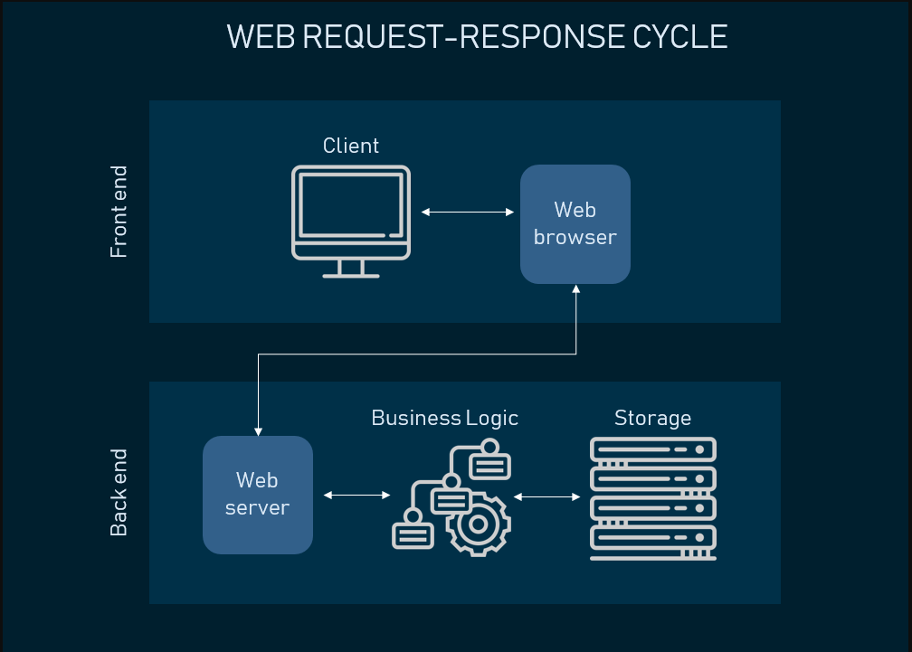

In web development, a website or web application is divided into two major parts:
- Frontend – what the user sees and interacts with
- Backend – how the system works behind the scenes
Both parts work together to make a complete and functional website.

Frontend Development (Client-Side)
Frontend development refers to the part of a website that is visible to users and runs in the web browser.
It focuses on user interface (UI) and user experience (UX).
🔹 Responsibilities of Frontend
- Designing page layout
- Displaying text, images, and videos
- Creating buttons, forms, and menus
- Handling user interactions (clicks, input)
- Making website responsive (mobile, tablet, desktop)

Technologies Used in Frontend
HTML, CSS , JavaScript , React/Angular

Backend Development (Server-Side)
Backend development refers to the part of a website that runs on the server and is not visible to users.
It controls logic, security, and data processing.
Responsibilities of Backend
- User authentication and authorization
- Processing requests from frontend
- Business logic implementation
- Database operations (insert, update, delete)
- Ensuring security and performance

Technologies Used in Backend
Java / Python / PHP, Node.js, Spring Boot / Django, MySQL / MongoDB

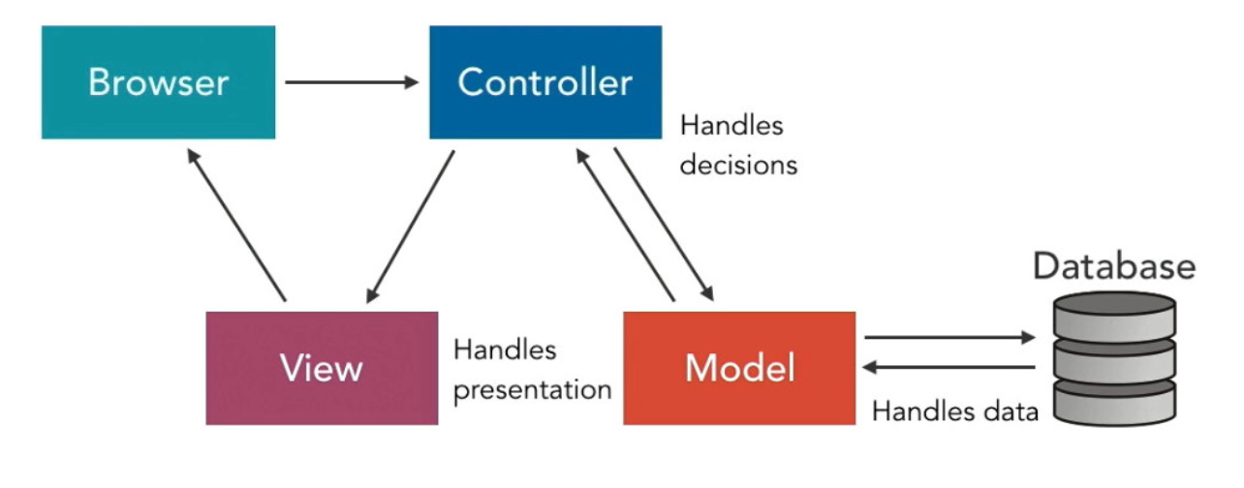

- Explain client–server communication with a neat diagram.
Client–server communication is a model in which a client (user’s device or browser) sends a request to a server, and the server processes the request and sends back a response.
This communication is the foundation of web applications, online services, email systems, and cloud computing.
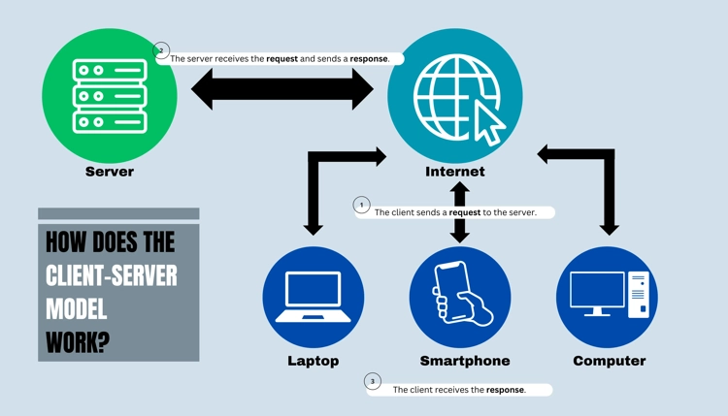
1. Client
- A client is a user-side application
- Examples: Web browser (Chrome), mobile app
- Role: Requests services or data
2. Server
- A server is a powerful system that provides services
- Examples: Web server, application server
- Role: Processes requests and sends responses
3. Network
- Medium through which data is transferred
- Usually the Internet
- Uses protocols like HTTP/HTTPS

Working of Client–Server Communication
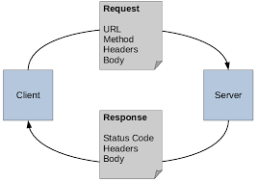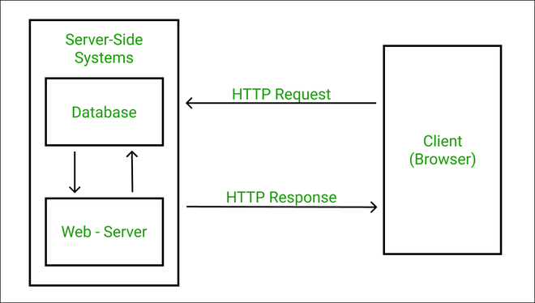

Step 1: Client Sends Request
Step 2: Server Receives Request
Step 3: Server Processes Request
Step 4: Server Sends Response
Step 5: Client Displays Response

- What is MEAN stack?
MEAN Stack is a full-stack web development technology stack used to build dynamic, scalable, and modern web applications using JavaScript at every layer of the application. 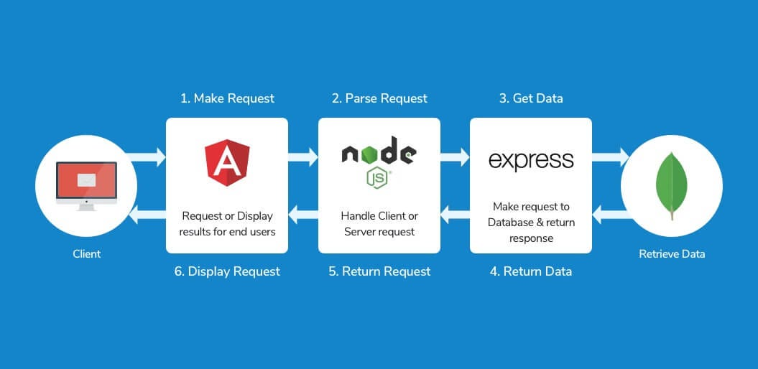
1. M-MongoDB (Database Layer)
- A NoSQL database
- Stores data in JSON-like documents
- Flexible and scalable
- Ideal for handling large amounts of data

2. E-Express.js (Backend Framework)
- A lightweight backend framework built on Node.js
- Simplifies server-side coding
- Handles routing, middleware, and APIs

3. A-Angular (Frontend Framework)
- A frontend framework used to build single-page applications (SPA)
- Runs in the browser
- Provides dynamic and interactive UI
- Communicates with backend using APIs

4. N-Node.js (Runtime Environment)
- JavaScript runtime that runs on the server
- Uses non-blocking, event-driven architecture
- Highly scalable and fast
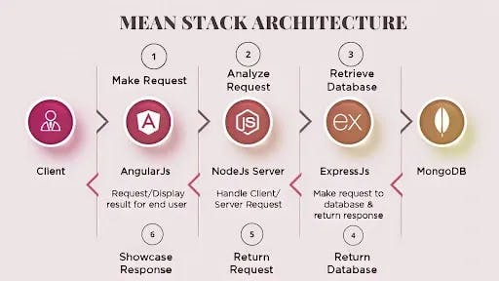

- User interacts with Angular frontend
- Angular sends request to Express server
- Express runs on Node.js
- Data is fetched/stored in MongoDB
- Response sent back to Angular
- UI updates on browser

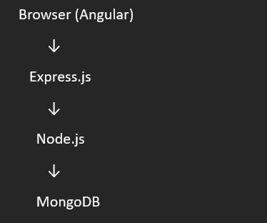

- Install Angular CLI using npm install -g @angular/cli
Angular CLI (Command Line Interface) is a tool used to:
- Create Angular projects
- Generate components, services, modules
- Build, run, and test Angular applications easily
It saves time by automating repetitive tasks.

Before installing Angular CLI, the system must have: Node.js
- Angular CLI works on Node.js
- Node.js includes npm (Node Package Manager)
Used to install Angular CLI (comes with Node.js

🖥️ Installation Process
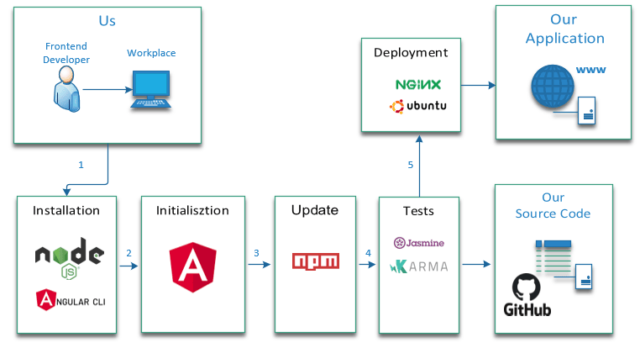

Step 1: Open Command Prompt / Terminal
- Windows → Command Prompt / PowerShell
Step 2: Install Angular CLI Globally
Run the command:
npm install -g @angular/cli
To Globally install and access from everywhere, allows you to use ng command anywhere.
Step 3: Verify Installation
ng version
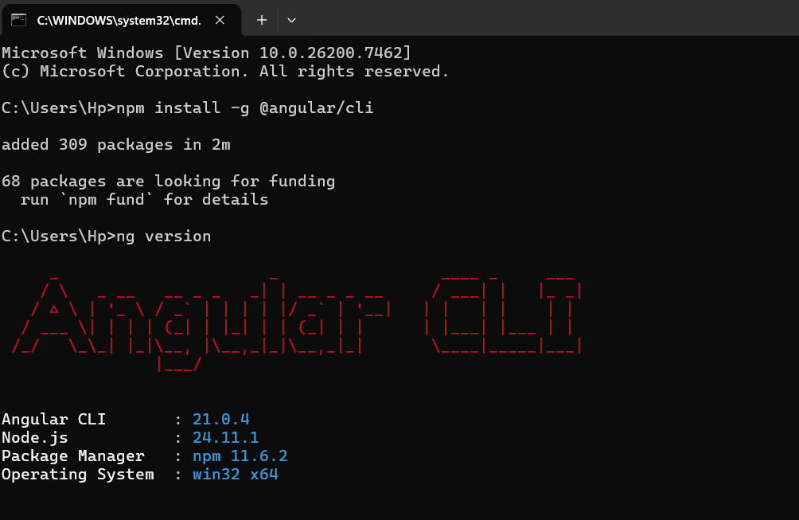

What Happens Internally?
- npm downloads Angular CLI package
- Files are installed globally on system
- ng command becomes available
- CLI can now create and manage Angular apps
Open in browser:
http://localhost:4200

- Draw the MEAN architecture workflow: Client (Angular) → Server (Express + Node.js) → Database (MongoDB)

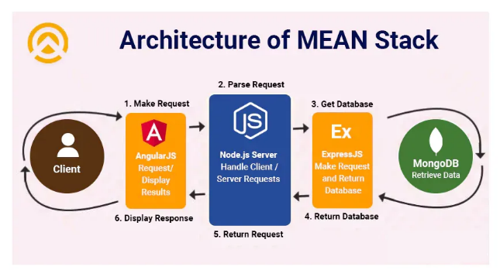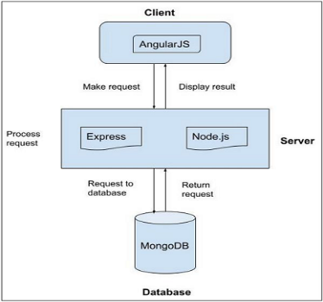

MEAN Stack Architecture Workflow
1. Client – Angular
- Runs in the user’s web browser
- Displays UI (forms, buttons, pages)
- Sends HTTP requests (GET, POST, PUT, DELETE)
- Receives response and updates UI
- For User Interface
2. Server – Express + Node.js
- Express handles routing and APIs
- Node.js executes backend JavaScript
- Processes client request
- Applies business logic
- Communicates with database

3. Database – MongoDB
- Stores data in JSON-like documents
- Performs CRUD operations
- Sends data back to server

4. Response Flow
- MongoDB → sends data to server
- Server → sends JSON response
- Angular → displays result to user

